****

**St. Michael’s House WorkAbility Project**

**Work Experience**

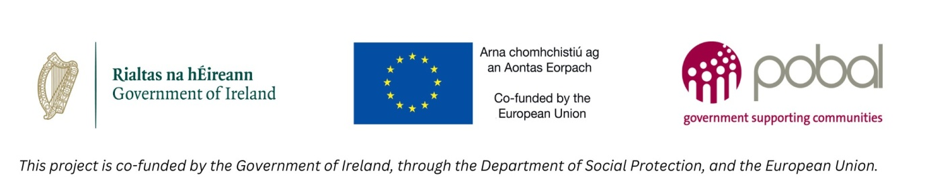

**Work Experience Placement Opportunity**

**Moogoo Skin Care**

****

|  |  |
| --- | --- |
| Location  Nore Road, Dublin Industrial Estate,  Dublin 11 | Screenshot 2024-11-29 at 14.27.02.jpeg  . |
| When  Starting 8th January 2024 | Date Jan 8.jpg |
| Day  Wednesday | Wednesday (2).jpg |
| Time  11am – 1pm | Time 11_00 (2).jpg |
| Duties  Making up boxes | 20241129_121106.jpg |
| Collecting Orders | 20241129_120900.jpg |
| Labelling Orders | 20241129_120909.jpg |

**How to apply:**

**Please send your CV or email of interest to** [**supportedemployment@smh.ie**](mailto:supportedemployment@smh.ie)

**Closing Date: Monday 9th December at 4pm**